October 5, 2022
Re: Public Comment File No. 2207-019 / 6950 SE Maker Street
Dear Ms. McGuire
Our names are Brigid Stackpool and Pamela Faulkner and our address is 7011 S.E. Maker St. We live below and diagonally southwest approx. ~50 feet from the proposed development site at the end of the upper portion of Maker St.
Critical/Steep Slope
As downhill neighbors, our primary concern is the environmental impact of this project. This property is located on the uphill portion of an escarpment in a landslide hazard zone on a 40-79% grade slope. (See table below) Based on the information on the Mercer Island city website, the potential of a disastrous outcome with the Strand build is high, even based on the Geotech report whose specs allow little margin for error on the location of the building. This is especially with regard to the setback requirements on the west slope of the property. Construction on this site, of what seems to be an overly large building for the size of the lot on such a steep grade, places all neighbors on this street, especially those of us below the site, at risk. One need only to look at the grade of Maker St. to see what the original slope of the proposed development site was originally. The amount of fill and grading required to create a level building area for the existing building had to have been substantial to make it level.
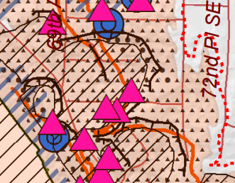 (Strand property noted with arrow)
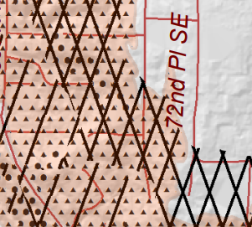

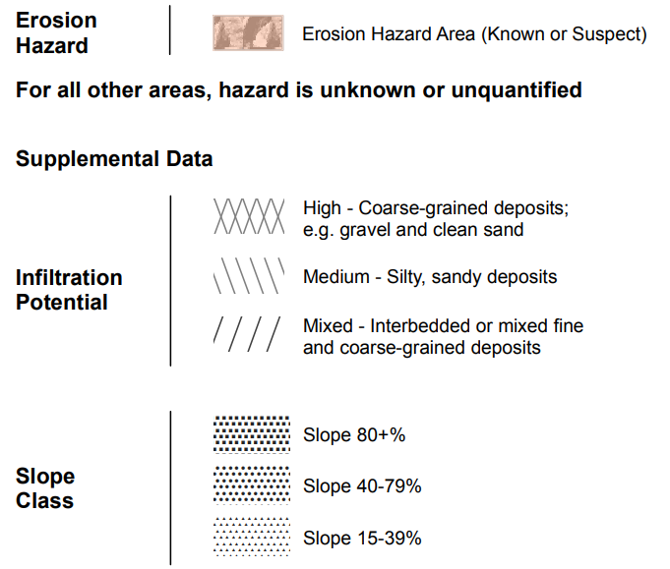
In 1981, previous building on this hillside at 7030 S.E. Maker (our neighbor across from us to the West of the subject property) resulted in the failure of the rockery on the westernmost slope of the Strand property. Please see the letter detailing this failure under Appendix A.
The DNR states “the presence of a previous landslide is one of the biggest and most obvious factors” determining whether there will be another landslide in that same area.
In the USGS published Landslide Handbook – A Guide to Understanding Landslides, they too state that previous landslides are predictable evidence of hillside vulnerability. (“Predictability Evidence of past earthflows is the best indication of vulnerability.” p. 23)
Additionally, the USGS explains that “triggering mechanisms include saturation of soil due to prolonged or intense rainfall or snowmelt, sudden lowering of adjacent water surfaces causing rapid drawdown of the ground-water table, stream erosion at the bottom of a slope, excavation and construction activities, excessive loading on a slope, earthquakes, or human-induced vibration.
The effect on surrounding areas (all neighboring properties to the Strand project) include “rapid, retrogressive earthflows that may devastate large areas of flat land lying above the slope and also may runout for considerable distances, potentially resulting in human fatalities, destruction of buildings and linear infrastructure.” p. 23)
Mercer Island city government should be aware of this risk and, if the Strand project is permitted, take responsibility for any damage or loss of life that may incur. However, the best mitigation is to avoid development activities near such slopes. (USGS, p. 22)
Finally, Mercer Island’s own building code restricts grading from Oct 1 – April 1. (Land clearing, grading, filling, and foundation work are not permitted between October 1 and April 1 on lots considered as an Erosion, Potential Slide, or Steep Slope Hazard)
While the Strand project lead may apply for a waiver, based on previous history of the failure of the rockery (Documented in Appendix A), it would seem ludicrous for the city to allow excavation at all on a hillside with it’s westernmost 20 feet so vulnerable to disturbance, especially during the rainy season.
We would like to see an independent secondary Geotech report be done on the building site. There seems to be particular vulnerability on the west boundary of the property in terms of soil disturbance within the setback area.
Tree Cutting for the Purpose of Development
On September 10th of 2021, our neighbor Susan Mattison informed us that she had learned that the huge Oak tree in Dan Groves yard at the top of Maker St just east of the subject property was going to be cut at the property line. We were shocked at this since the structure of the tree is a split trunk and the sheer size of that portion of the tree was immense. We were suspicious that there was a motivation to do this on Strand’s part because she wanted to build up. A big clue was that it was conveyed that there was denial that this was being done for the purpose of development but was instead based on Strand’s annoyance at “acorns dropping on her roof and waking her up.” Susan contacted John Kenney by email (Brigid CC’d,) on 9/14/21 to ask him his thoughts on what we could do to protect the tree (an exceptional tree by definition) whose survival was in question since the large branch of the tree, if cut at the property line, would not only make it unsightly but would chop off a good third of the west side and crown of the tree. Kenney responded with “I think this is the tree the owner and I discussed. It does look like the trunk leaning over the structure could benefit from a few rounds of pruning over 5 years. This would help the trees and the neighbor. The problem is people usually want immediate results and not slow changes. It is also more expensive to have a crew out yearly to do a small reduction.” He was informed that the tree had just been pruned at the end of 2020 by an arborist hired by Dan Grove who owns the tree. It was hard to see how it could have been improved upon by “a few rounds of pruning” since the beauty of the tree had been preserved by a professional one year prior.
On November 10th, a logging company came out with a huge boom to chop the tree. This was approximately one week after the original tree company that came out to do the job didn’t have equipment large enough to butcher the west trunk of the legacy oak tree. All of us on the street were just sick over it. It was clearly a hatchet job and that there must be more to the story which indeed there was.
We discovered that before this whole tree fiasco that on September 22nd of 2021 there were questions posed to the city by Strand specific to drainage issues and future development of her property.
Then on October 11th, 2021, Strand submitted a site development worksheet. Obviously, this was for the purpose of developing the property and seems to be a clear violation of MI Code referencing exceptional trees, especially with regard to construction/development. Also, that same day, Susan wrote McHarg and Kenney (I was CC’d) stating that she was aware of the submission of the CPD pre application PRE21-053 and wanted to know how the Strand situation differed from a developer purchasing the property specifically for that purpose.
Kenney stated that “this is a bit of a grey area in the code and we will discuss this further. Generally trees can be pruned to our standards without a permit. Development occurs at 500 sq’ of new impervious surface or gross floor area.” The application submitted by Strand specifically stated a request to expand by 1000 feet. I fail to see the grey area. It seems to be clearly black and white. Strand needed a permit to remove such a significant portion of an exceptional tree with the expressed purposed of developing the property and should have been held accountable for breaking MI code.
Since taking possession of the property in April of 2021, Ms. Strand has removed every significant piece of vegetation on the property. She removed a tree at the top of the vulnerable west slope of the subject property ~25 ft tall (which in the Superior NW Enterprises dated August 16, 2022 is stated as “not present” and erroneously presumed to be removed by the previous owners) all of the arbor vitae that borders the northwest side of the property, all of the laurel on the north side. She tried to strong arm my neighbor to the north on the downward sloping west side of the rock wall aforementioned, in order to get her to top her trees and improve her view by threatening to claim the rock wall was hers (Strand’s) and that she was going to put a construction fence at the bottom of it right next to her front porch. One has to wonder why in April of 2021 that she would suggest a construction fence if she weren’t planning to develop the property not to mention the social disfunction of this behavior toward whom she claims are going to be her future neighbors.
The removal of all of this vegetation, whether it be a violation of code or not, has an effect on the stability of the soil on her property and the hillside itself. Not only the removal of root systems but also the amount of water that all of those shrubs and tree suck up and now are not present to do the job. Perhaps this was all done to avoid having to do a tree preservation plan or another attempt to improve her view, we can only speculate.
Based on our experience with the destruction of the legacy oak tree and the City’s neglect in noting that the owner had already specifically made clear her intent to develop the property and was therefore violating MI tree code, we have doubts that the City will have sufficient oversight of this project if it allowed to move forward. There are clearly staffing and budget issues contributing to lack of oversight of building and exceptional tree code enforcement, which does nothing to alleviate our concern regarding this project but rather intensifies those concerns. In other words, we are thinking you are all pretty stretched on capacity. Our biggest fear is that the Strand project builders are permitted to move ahead without following Mercer Island’s own building codes (it already happened with the exceptional tree!) and we will experience a failure of the rock wall on the western slope of the property in a weather or seismic event. Considering the steep/critical slope instability and drainage problems, our homes below Strand will experience considerable damage or worse with no one being held accountable for permitting this un-permittable project.
Access and driveway blockage
As previously mentioned, we live at the bottom Maker St which dead ends. This proposed project is kitty corner from our lot and the road is very narrow. Access to the site where this is to take place is very limited and there will be virtually no parking on the subject property since they will be working on it with no access to public parking. If the road is blocked with vehicles or equipment, we won’t be able to get out since there is only one way in and one way out. Likewise, in an emergency, we are concerned that first responder vehicles will be unable to get to our homes. We want to know the plan for insuring we can leave our property as well as in the event of an emergency or other services that will require access to our property.
Conclusion
Unfortunately, our experience so far with regard to anything to do with this particular individual and the city leave us feeling apprehensive about this project going forward. It is my sincere hope that you or one of the other staff members in planning will get out of your office and come walk this site in order to make your own assessment. It also our sincere wish that you review the mountain of evidence Strand’s neighbors have presented and deny her to move ahead with this planned project.
Sincerely,
Brigid Stackpool & Pamela Faulkner

Appendix A

